|  |  |  |  |  |  |  |  |  |  |
| --- | --- | --- | --- | --- | --- | --- | --- | --- | --- |
| **SCHOOLOFCOMPUTER SCIENCE AND ARTIFICIAL INTELLIGENCE** | | | | | **DEPARTMENTOFCOMPUTER SCIENCE ENGINEERING** | | | | |
| **ProgramName:**B. Tech | | | | **AssignmentType: Lab** | | | **AcademicYear:**2025-2026 | | |
| **CourseCoordinatorName** | | | | Venkataramana Veeramsetty | | | | | |
| **Instructor(s)Name** | | | | |  | | --- | | Dr. V. Venkataramana (Co-ordinator) | | Dr. T. Sampath Kumar | | Dr. Pramoda Patro | | Dr. Brij Kishor Tiwari | | Dr.J.Ravichander | | Dr. Mohammand Ali Shaik | | Dr. Anirodh Kumar | | Mr. S.Naresh Kumar | | Dr. RAJESH VELPULA | | Mr. Kundhan Kumar | | Ms. Ch.Rajitha | | Mr. M Prakash | | Mr. B.Raju | | Intern 1 (Dharma teja) | | Intern 2 (Sai Prasad) | | Intern 3 (Sowmya) | | NS_2 ( Mounika) | | | | | | |
| **CourseCode** | | | 24CS002PC215 | **CourseTitle** | | AI Assisted Coding | | | |
| **Year/Sem** | | | II/I | **Regulation** | | R24 | | | |
| **DateandDay**  **of Assignment** | | | Week5 - WednesDay | **Time(s)** | |  | | | |
| **Duration** | | | 2 Hours | **Applicableto**  **Batches** | |  | | | |
| **AssignmentNumber:10.1**(Presentassignmentnumber)/**24**(Totalnumberofassignments) | | | | | | | | | |
|  | **Q.No.** | **Question** | | | | | | ***ExpectedTime***  ***to complete*** |  |
|  | 1 | **Lab 10 – Code Review and Quality: Using AI to Improve Code Quality and Readability**  **Lab Objectives**   * Use AI for automated code review and quality enhancement. * Identify and fix syntax, logical, performance, and security issues in Python code. * Improve readability and maintainability through structured refactoring and comments. * Apply prompt engineering for targeted improvements. * Evaluate AI-generated suggestions against PEP 8 standards and software engineering best practices   **Task Description #1 – Refactor Nested Conditionals**  Task: Provide AI with the following nested conditional code and ask it to simplify and refactor for readability.  **Python script.**  def discount(price, category):  if category == "student":  if price > 1000:  return price * 0.9  else:  return price * 0.95  else:  if price > 2000:  return price * 0.85  else:  return price  **Expected Output:**   * Refactored code using cleaner logic, possibly a dictionary or separate helper functions.   **Task Description #2 – Optimize Redundant Loops**  Task: Give AI this messy loop and ask it to refactor and optimize.  **Python script**  def find_common(a, b):  res = []  for i in a:  for j in b:  if i == j:  res.append(i)  return res  **Expected Output:**  Cleaner version using Python sets (set(a) & set(b))  **Task Description #3 – Improve Class Design**  **Task:** Provide this class with poor readability and ask AI to improve:   * Naming conventions * Encapsulation * Readability & maintainability   **Python Script**  class emp:  def __init__(self,n,s):  self.n=n  self.s=s  def inc(self,p):  self.s=self.s+(self.s*p/100)  def pr(self):  print("emp:",self.n,"salary:",self.s)  **Expected Output:**   * Employee class with meaningful methods (increase_salary, display_info), formatted output, and added docstrings.   **Task Description #4 – Modularize Long Function**  Task: Give AI this long unstructured function and let it modularize into smaller helper functions.  **Python Script**  def process_scores(scores):  total = 0  for s in scores:  total += s  avg = total / len(scores)  highest = scores[0]  for s in scores:  if s > highest:  highest = s  lowest = scores[0]  for s in scores:  if s < lowest:  lowest = s  print("Average:", avg)  print("Highest:", highest)  print("Lowest:", lowest)  **Expected Output:**   * Split into functions: calculate_average, find_highest, find_lowest. * Clean main process_scores() using helper functions.   **Task Description #5 – Code Review on Error Handling**  Task: Provide AI with this faulty code and ask it to improve error handling, naming, and readability.  **Python Script**  def div(a,b):  return a/b  print(div(10,0))  **Expected Output:**   * Function with proper error handling using try-except. * Better naming (divide_numbers). * AI-generated docstring explaining error handling.   **Task Description #6 – Complexity Reduction**  Task: Use AI to simplify overly complex logic.  Sample Input Code:  def grade(score):  if score >= 90:  return "A"  else:  if score >= 80:  return "B"  else:  if score >= 70:  return "C"  else:  if score >= 60:  return "D"  else:  return "F"  Expected Output:   * Cleaner logic using elif or dictionary mapping. | | | | | | Week5 - Monday |  |

***TASK 01***

Code :

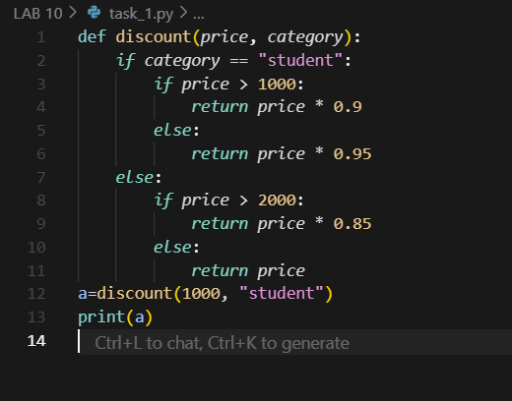

Output :

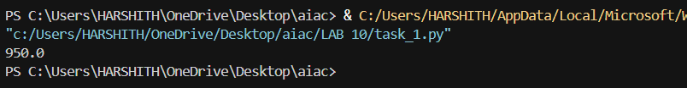

Refactored code :

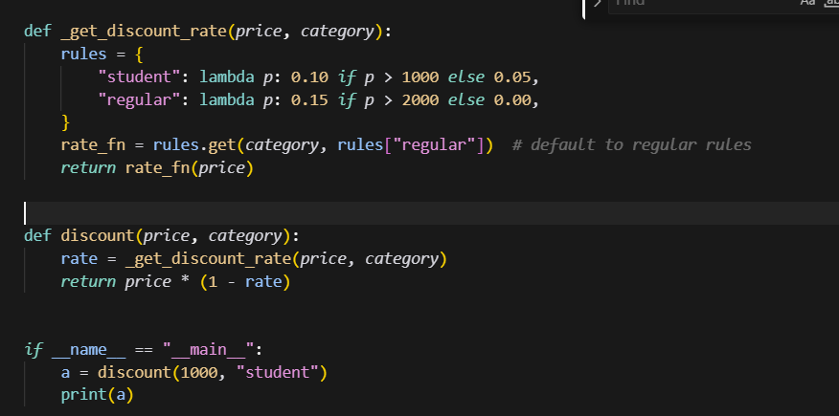

Output :

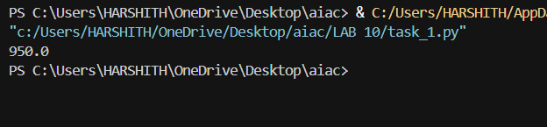

***TASK 02 ***

Code :

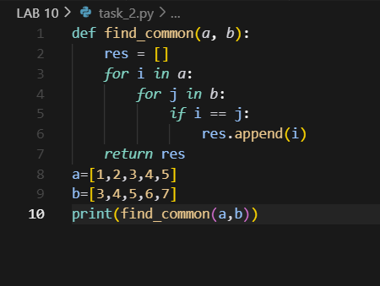

Output :

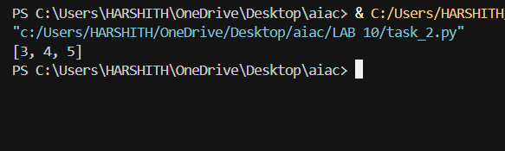

Refactored code :

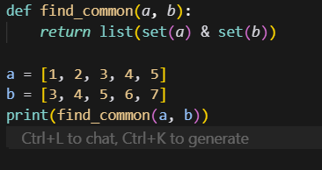

Output :

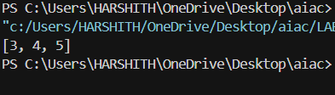

***TASK 03***

Code :

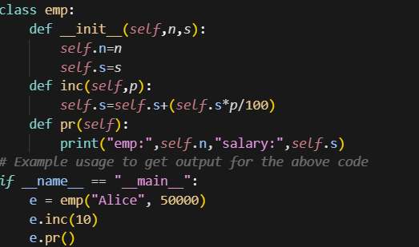

Output :



Refactored Code :

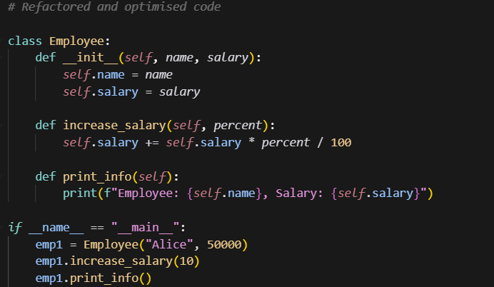

Output :



***TASK 04***

Code :

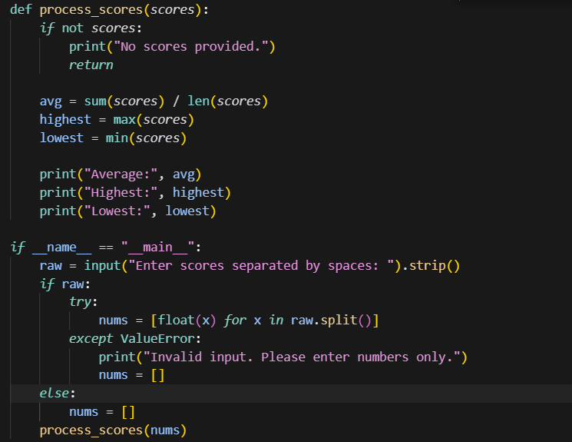

Output :

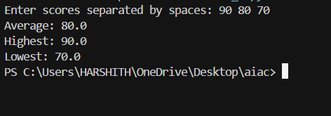

Refactored Code :

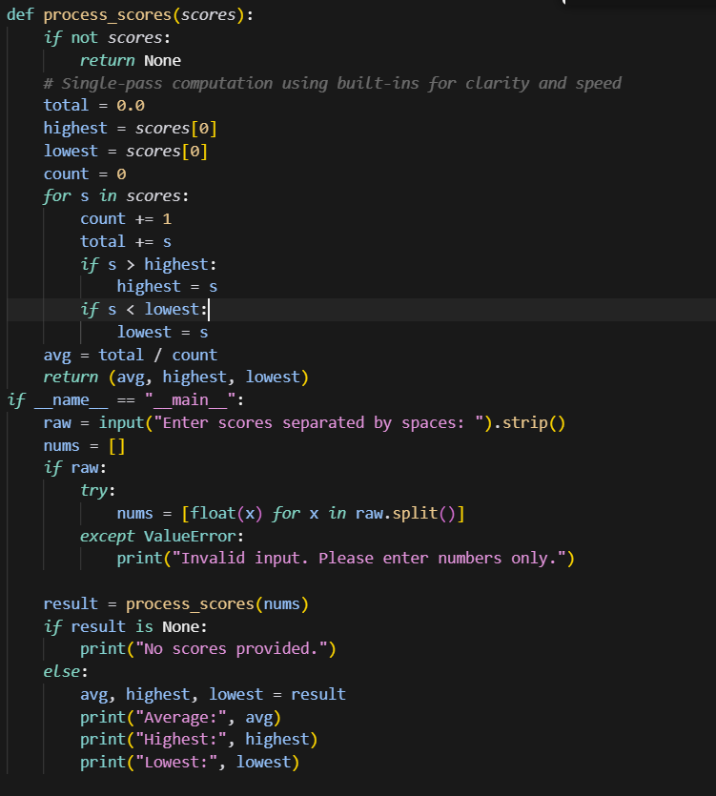

Output :

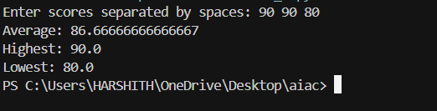

***TASK 05***

Code :

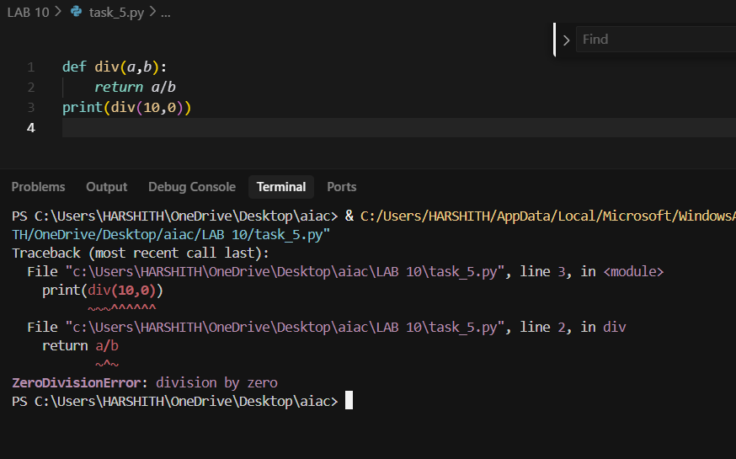

Refactored Code :

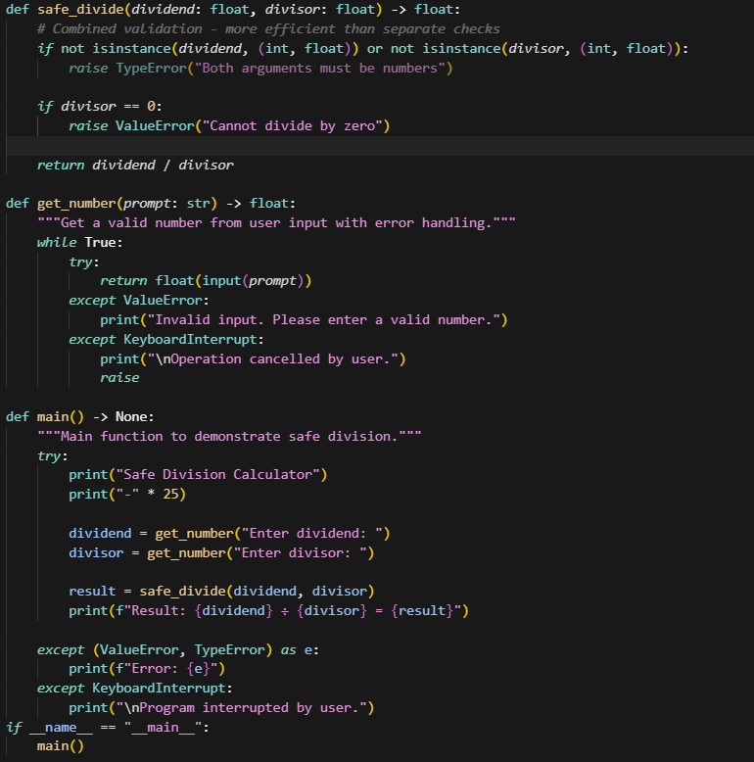

Output :

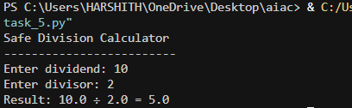

***TASK 06***

Code :

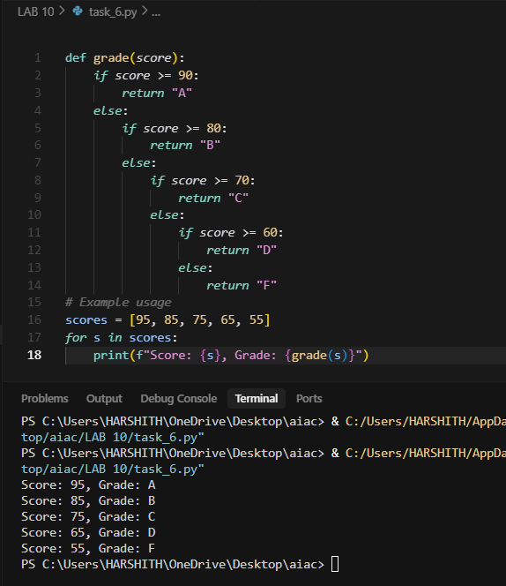

Refactored code :

